7.1.1)Write a Mapreduce program to modify Sales of different TV Task 2 ( refer session 5 assignment 2 ) to use a custom partitioner with 4 reducers. Make sure that all records whose company name starts with A-F (upper or lower case) should go to 1st reducer, those starting with G-L to 2nd reducer, those starting with M-R to 3rd reducer and others to 4th reducer

DRIVER:

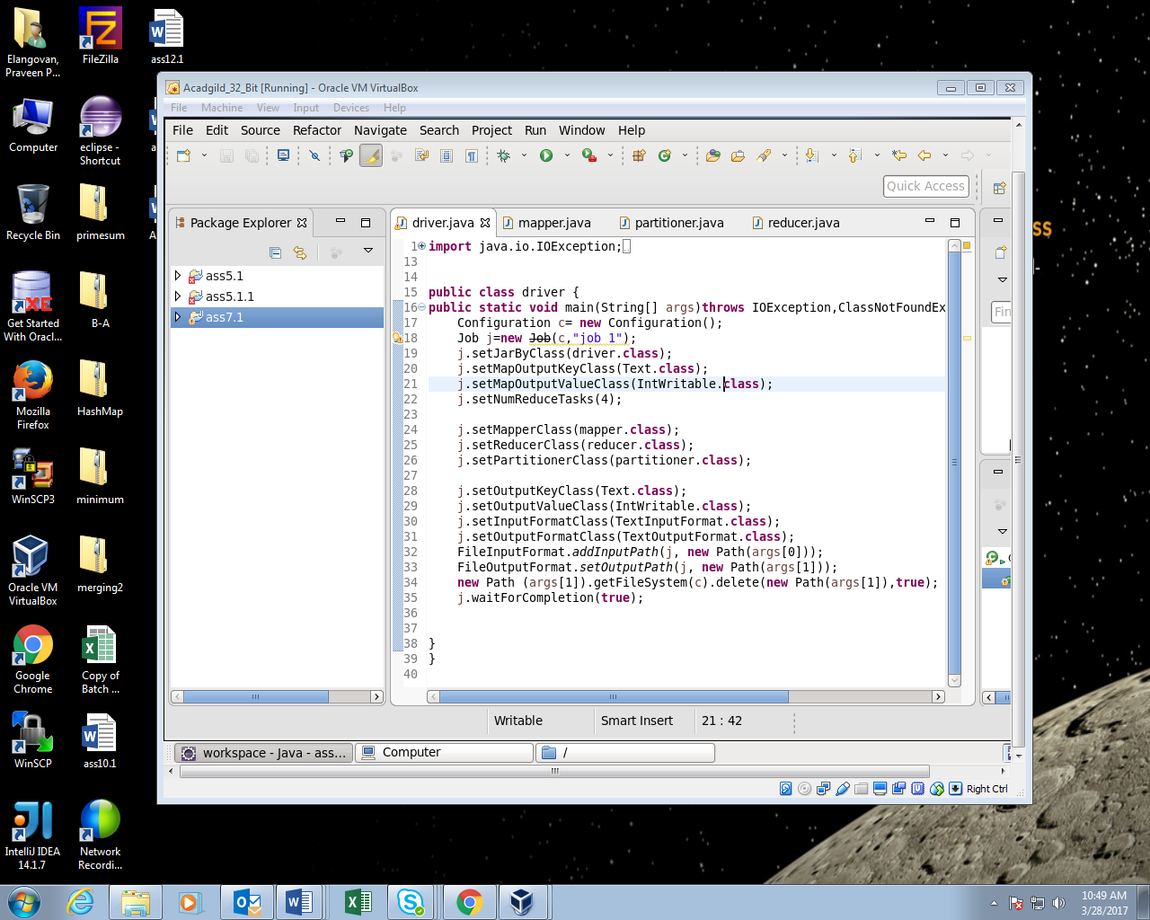

Mapper:

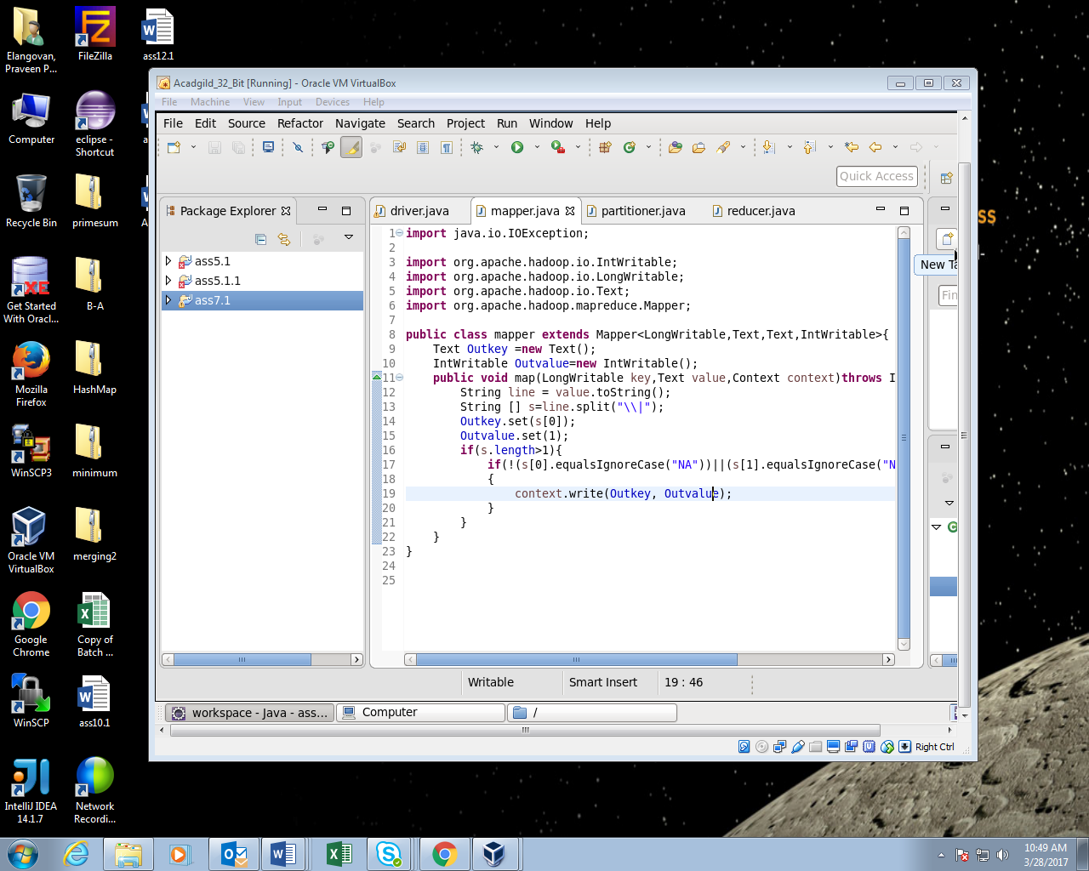

Partitioner:

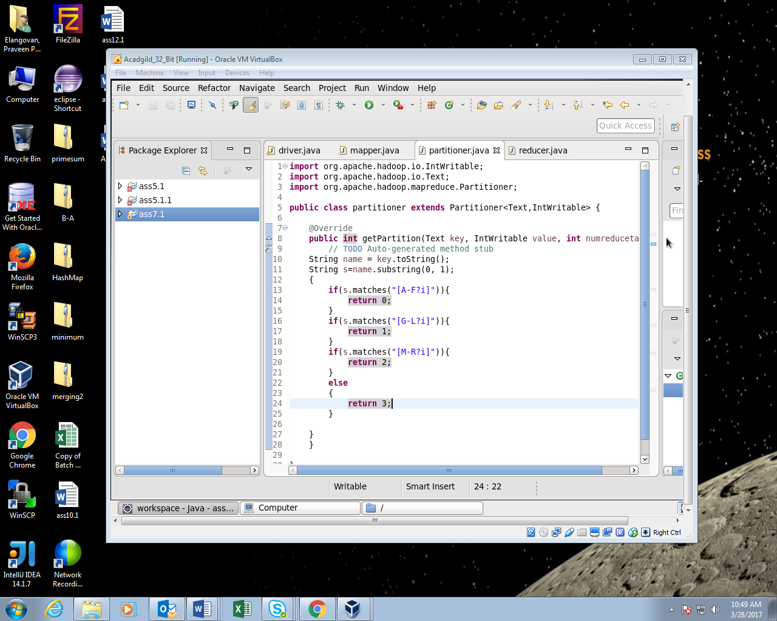

Reducer:

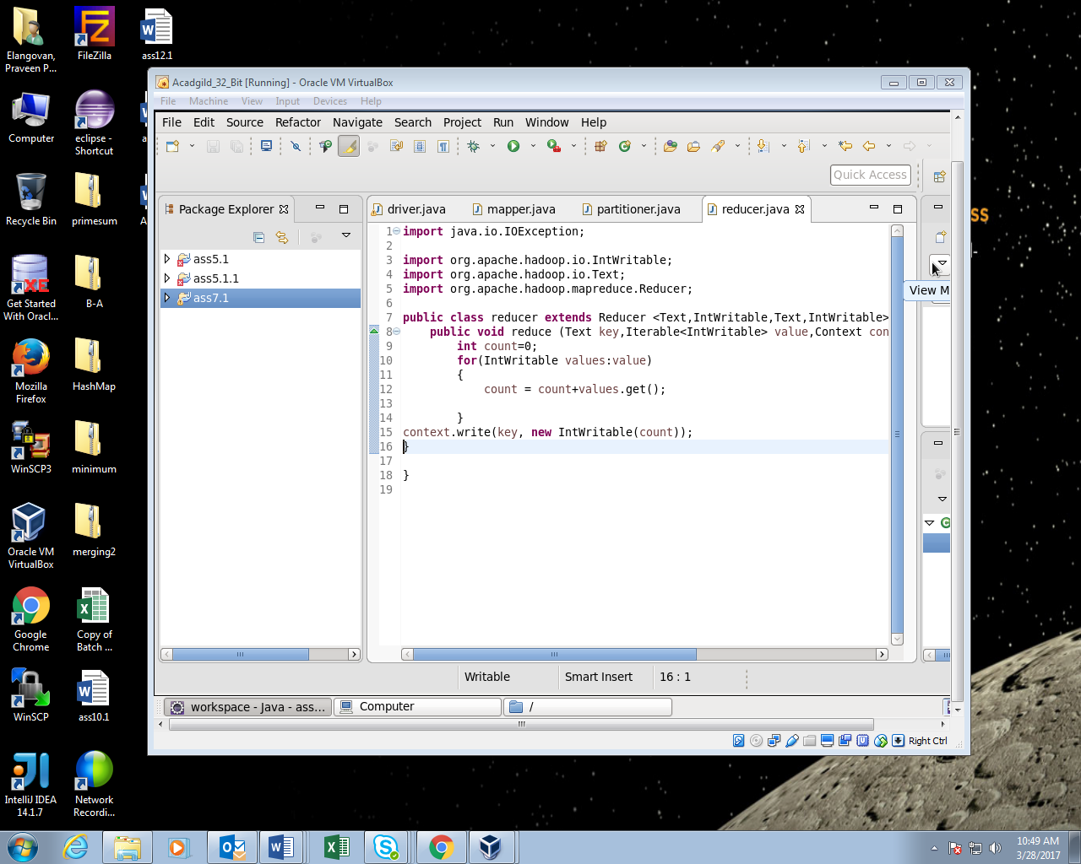

Running jar:

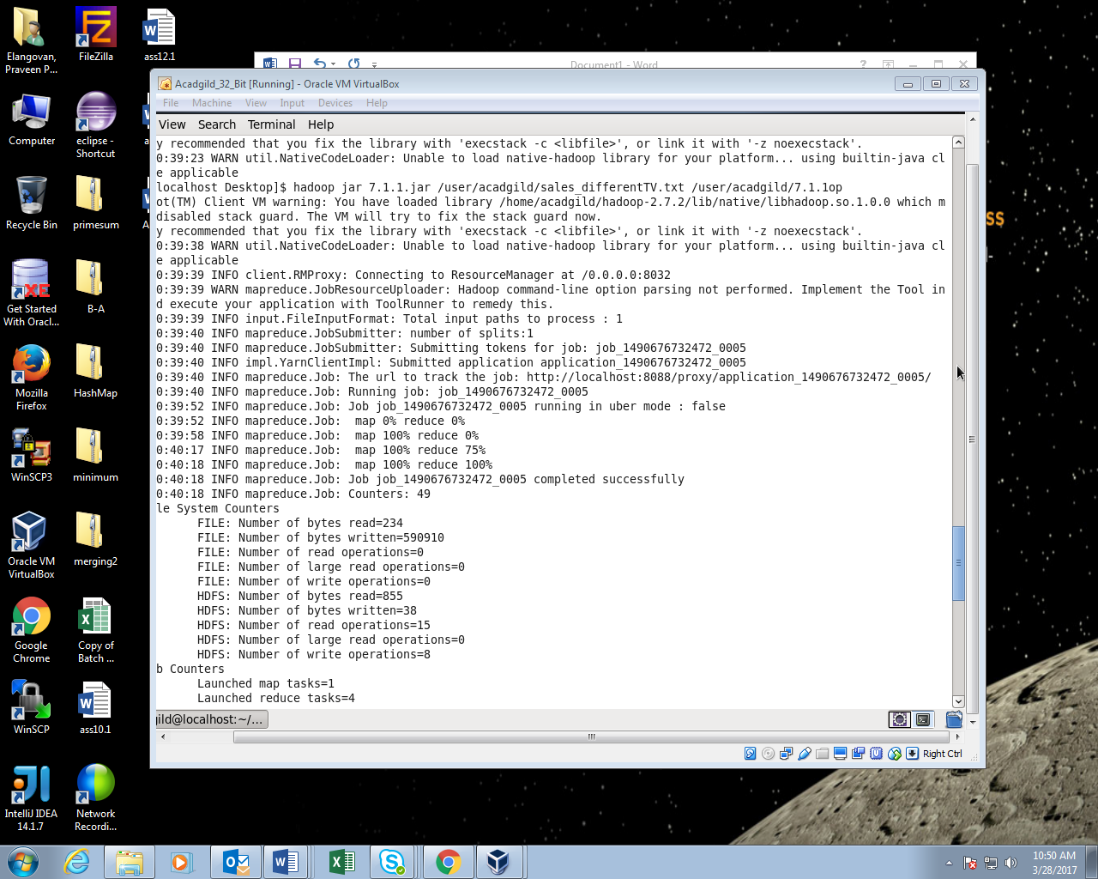

Output:

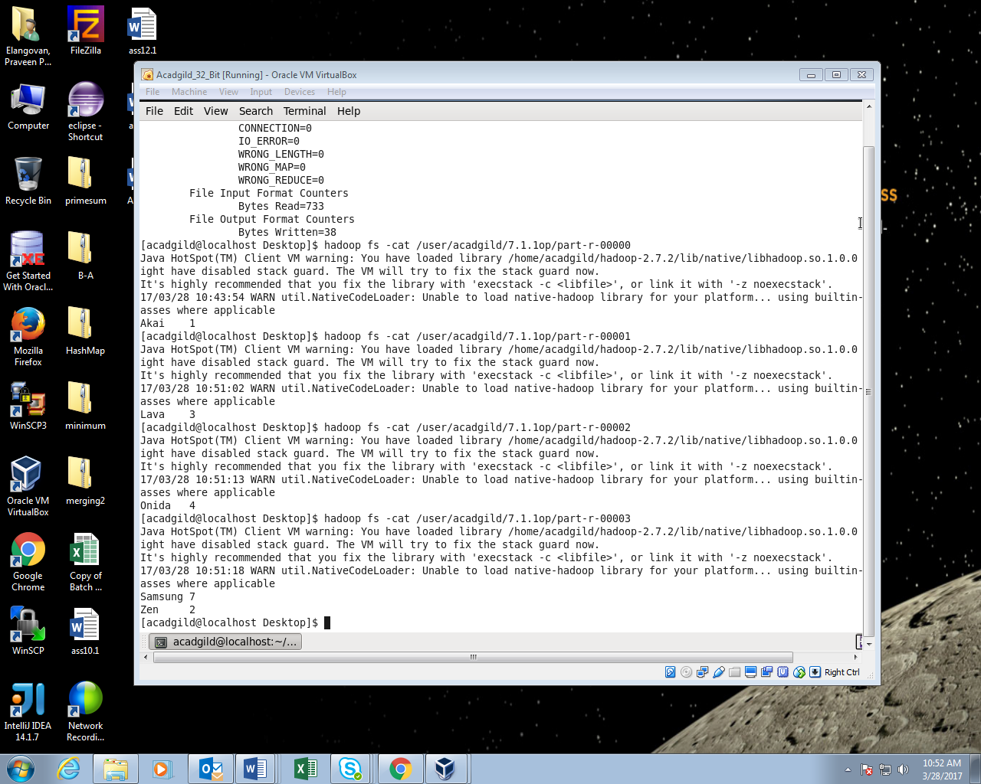

2) Modify Sales of different TV Task 2 (refer session 5, assignment 2) to take advantage of Combiner

DRIVER:

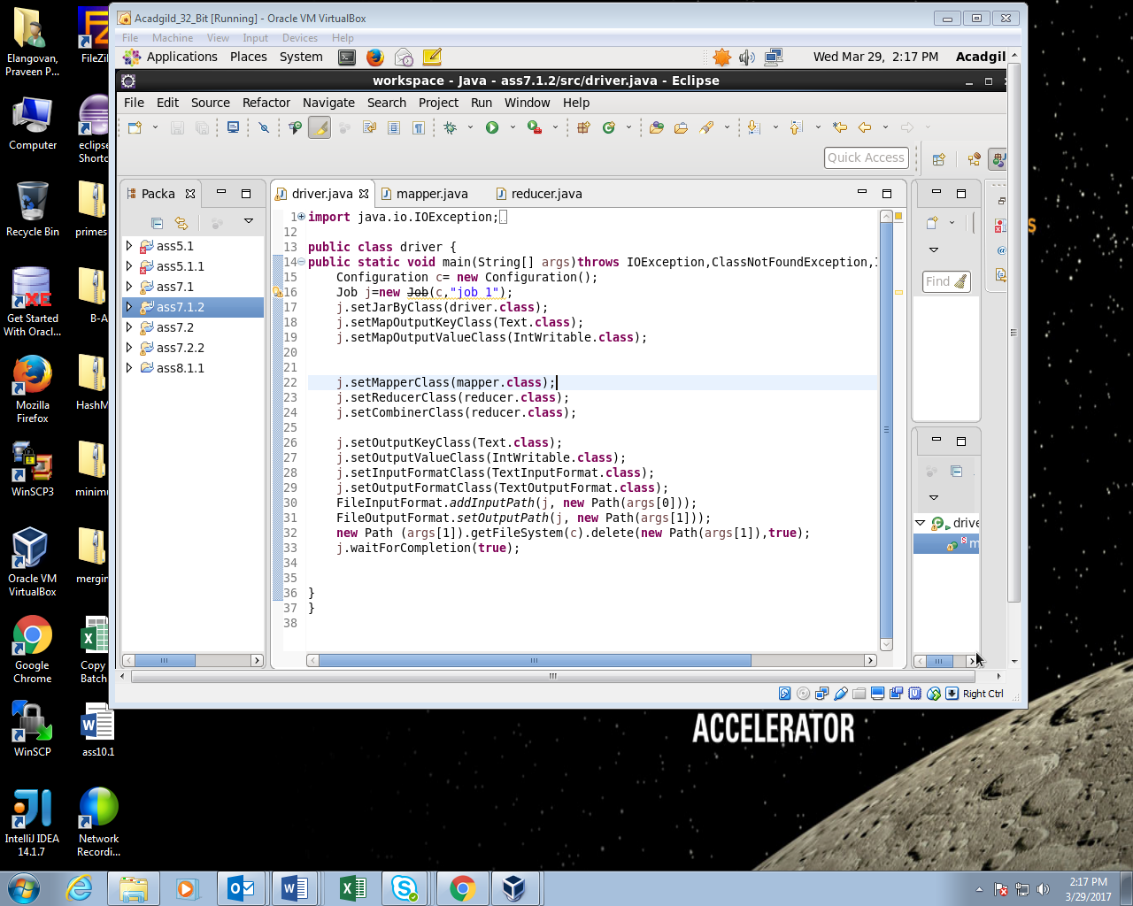

MAPPER:

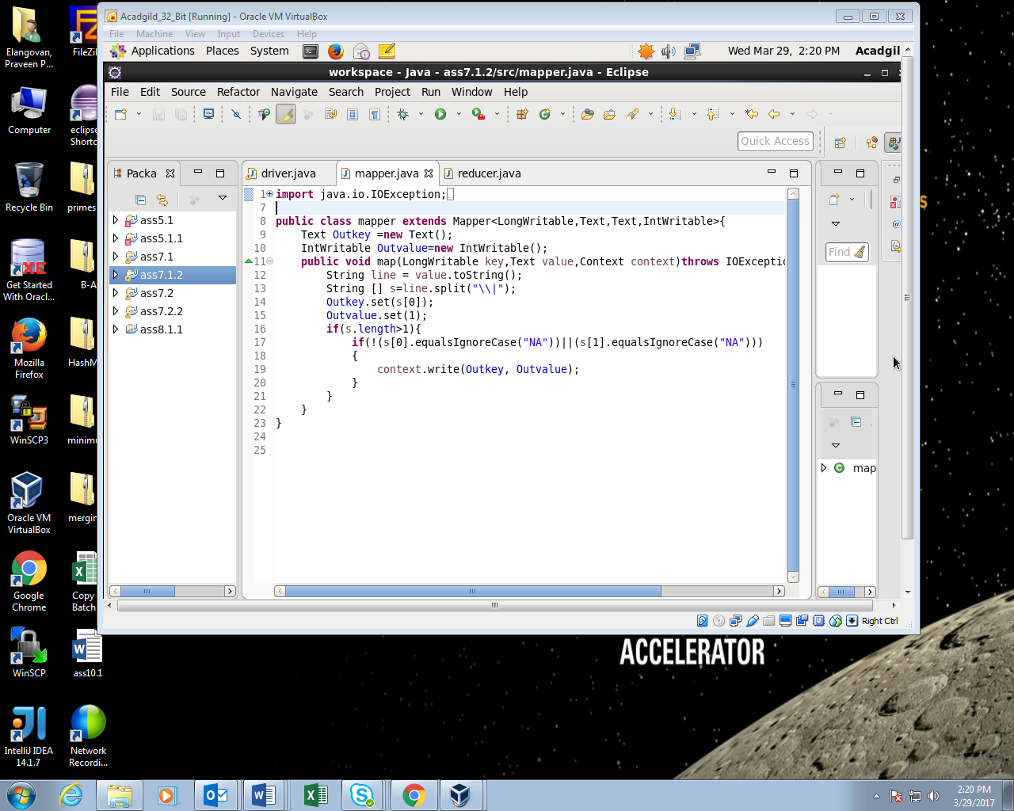

REDUCER:

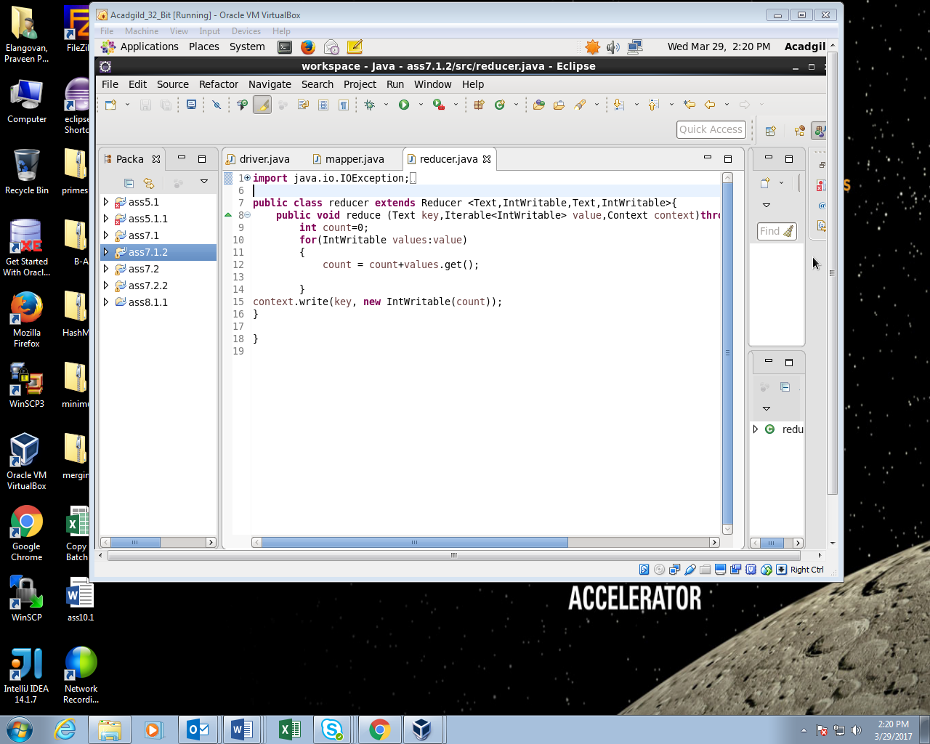

RUNNING JAR:

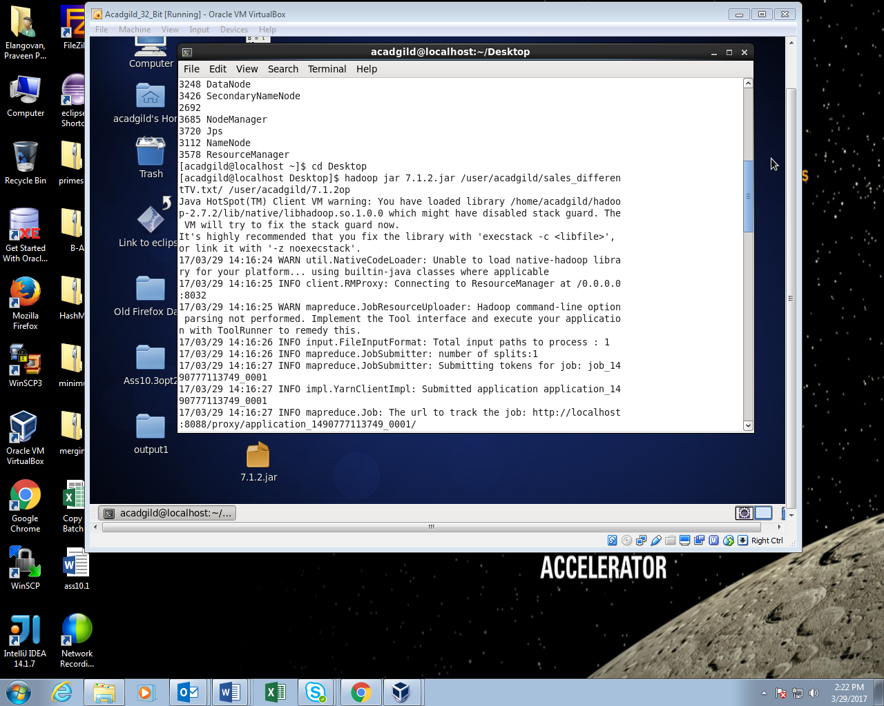

OUTPUT:

